Leland Adams

**Homework 2**

Remember that your programs must read the data from the text files exactly as they appear. You may not edit the text files to make them more convenient for SAS. Turn in the code, log file and output. If any of these 3 items is missing then you will not be graded for that question. Use the snipping tool instead of screen shots and make sure the font is large enough for me to read.

'\\Client\C$\Users\Leland\Desktop\ISM6930 SAS\mydata.txt';

1. Refer to the CATS1 dataset. Write a SAS program to read the data file from your USB with an INFILE statement and print the dataset. There should be eight observations and two variables.

**CODE**

**data** cats1;

infile '\\Client\C$\Users\Leland\Desktop\ISM6930 SAS\cats1.txt';

input Cat $ Side $ @@;

**run**;

**proc** **print** data = cats1;

**run**;

**LOG**

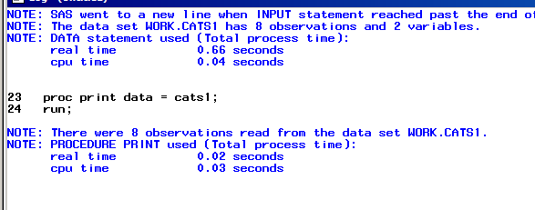

**OUTPUT**

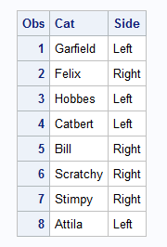

1. Refer to the DOGS1 dataset. Write a SAS program to read the data file from your USB with an INFILE statement and print the dataset. There should be 25 observations and six variables.

**CODE**

**data** dogs1;

infile '\\Client\C$\Users\Leland\Desktop\ISM6930 SAS\dogs1.txt' firstobs = **2**;

input Dog $ Conc **16** Sex $ **17** Age **31**-**32** Haircoat $ @**32** Weight **43**-**48**;

**run**;

**proc** **print** data = dogs1;

**run**;

**LOG**

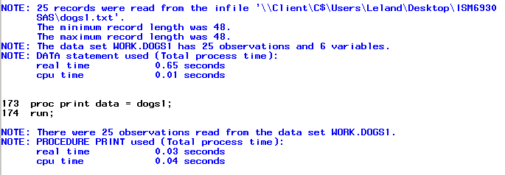

**OUTPUT**

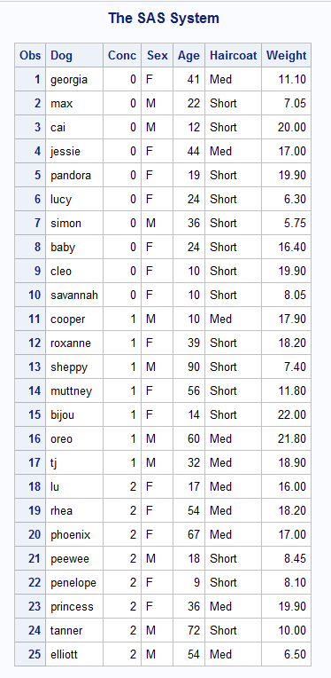

1. Refer to the BREAD dataset. Write a SAS program to read the data file from your USB with an INFILE statement and print the dataset. There should be 11 observations and 11 variables.

**CODE**

**data** bread;

infile '\\Client\C$\Users\Leland\Desktop\ISM6930 SAS\bread.txt' dlm = ','firstobs = **3**;

input Dough $ Water Oil Sugar Salt DryMilk Flour Yeast Wheat Oregano Eggs;

**run**;

**proc** **print** data = bread;

**run**;

**LOG**

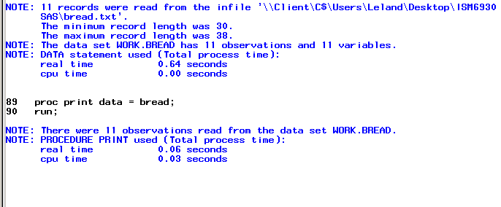

**OUTPUT**

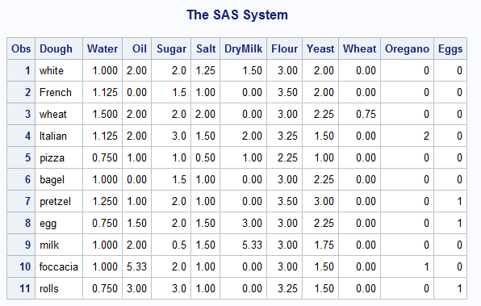

1. Refer to the GRADES dataset. Write a SAS program which uses a DATALINES command, not an INFILE statement and print the dataset. Copy and paste the numbers from the text file into your SAS program.

**CODE**

**data** grades;

infile datalines delimiter='/';

input Name $ Quiz Test Project $ Absences;

datalines;

Ann/84/90/A-/0

Bill/78/84/B/0

Cathy/95/89/A/1

David/84/88/B+/1

;

**run**;

**proc** **print** data = grades;

**run**;

**LOG**

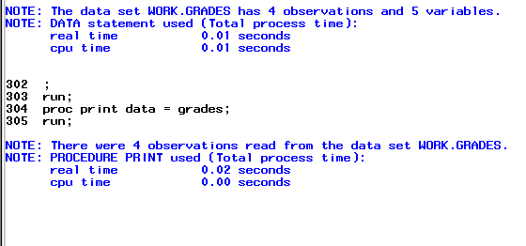

**OUTPUT**

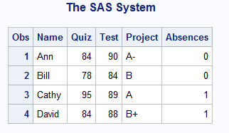

1. Refer to the SOCCER dataset. Write a SAS program to read the data file from your USB with an INFILE statement and print the dataset. Read the feet and inches in the heights of the players as two separate variables. There should be 32 observations and 8 variables. Make sure that your program correctly interprets Lynn Pattishall’s jersey number as 00.

**CODE**

**data** soccer;

informat lastname $13.;

infile '\\Client\C$\Users\Ultron\Desktop\ISM6930 SAS\soccer.txt';

input Jersey $ **1**-**2** / FirstName $ LastName $ /

Position $ /Feet **1** Inches **3** /

Grade $ / Something $;

**run**;

**proc** **print** data=soccer;

var jersey firstname lastname position feet inches grade something;

**run**;

**LOG**

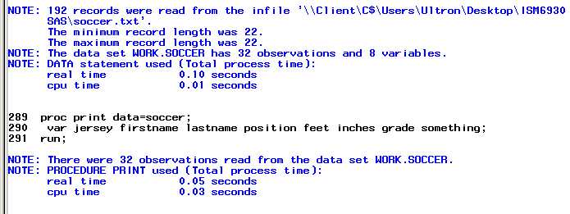

**OUTPUT**

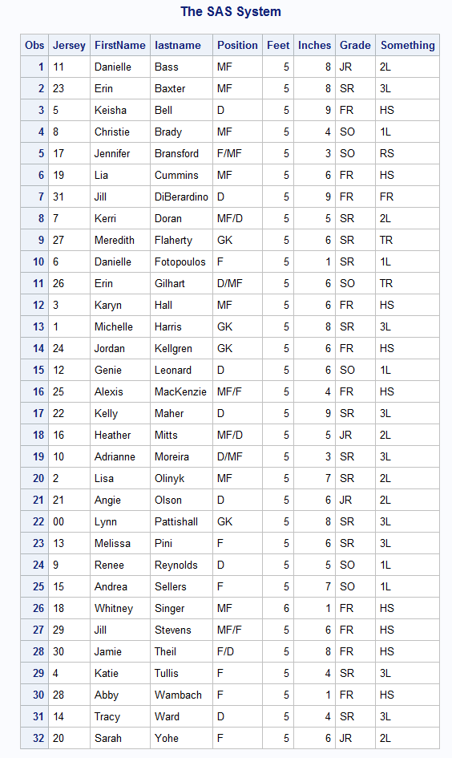

1. Refer to the CATS3 dataset. Write a SAS program to read the data file from your USB with an INFILE statement, write a permanent SAS dataset onto your USB, and print the dataset. There should be 8 observations and five variables.

**CODE**

**data** cats;

infile '\\Client\C$\Users\Leland\Desktop\ISM6930 SAS\cats3.txt' firstobs = **2**;

input Cat $ Side $ Week0 Week1 Week2;

**run**;

libname saslib '\\Client\C$\Users\Leland\Desktop';

**data** saslib.cats;

set cats;

**proc** **print** data = saslib.cats;

title 'cats';

**run**;

**LOG**

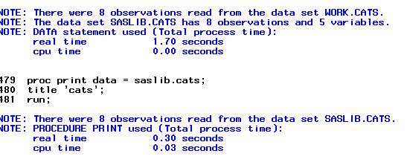

**OUTPUT**

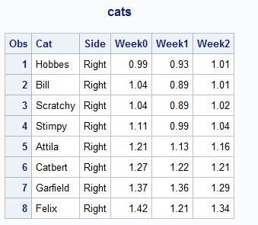

1. Refer to the MANATEES dataset. Write a SAS program to read the data file from your USB with an INFILE statement and print the dataset. There should be 23 observations and seven variables.

**CODE**

**data** manatees;

infile '\\Client\C$\Users\Ultron\Desktop\ISM6930 SAS\manatees.txt' dlm='09'x firstobs = **2**;

input Year Waterc Lock Relat Perin Natur Undet;

**run**;

**proc** **print** data = manatees;

**run**;

**LOG**

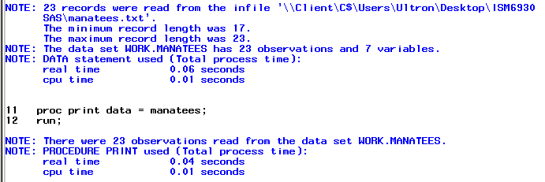

**OUTPUT**

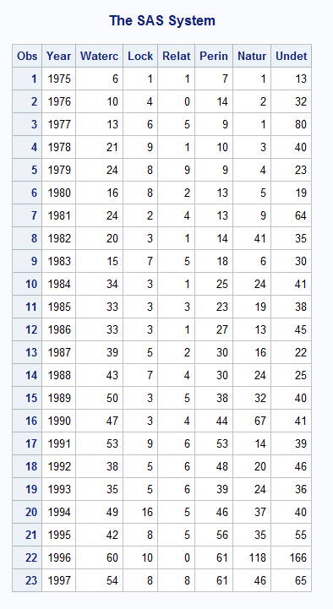

1. Refer to the DOGS2 dataset. Write a SAS program to read the data file from your USB with an INFILE statement, write a permanent SAS dataset onto your USB, and print the dataset. There should be 25 observations and four variables.

**CODE**

**data** dogs;

infile '\\Client\C$\Users\Ultron\Desktop\ISM6930 SAS\dogs2.txt' dlm = '09'x firstobs = **3**;

input DogName $ Week0 Week2 Week4;

**run**;

libname animals '\\Client\C$\Users\Ultron\Desktop';

**data** animals.dogs;

set dogs;

**proc** **print** data = animals.dogs;

title 'dogs';

**run**;

**LOG**

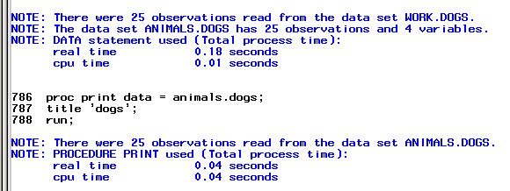

**OUTPUT**

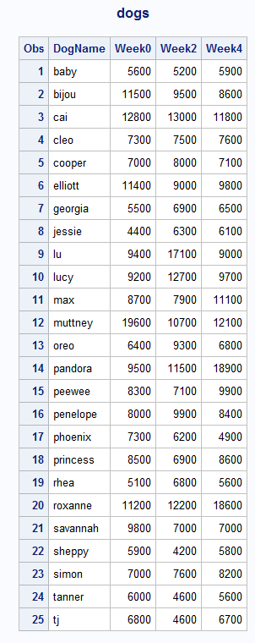

1. Use stocks.txt which contains a stock symbol, a price, and the number of shares.
2. Using this raw data file, create a temporary SAS data set (Portfolio). Choose your own variable names for the stock symbol, price, and number of shares. In addition create a new variable (call it Value) equal to the stock price times the number of shares. Include a comment in your program, your name, and the date the program was written.
3. Write the appropriate statements to compute the average price and the average number of shares of your stocks.

**CODE**

/* Leland Adams 5-19-2015 */

**data** portfolio;

infile '\\Client\C$\Users\Ultron\Desktop\ISM6930 SAS\stocks.txt';

input StockSymbol $ Price Shares;

Value = price * shares;

**run**;

**proc** **print** data=portfolio;

title portfolio;

**run**;

**proc** **means** data=portfolio;

var price shares;

**run**;

**LOG**

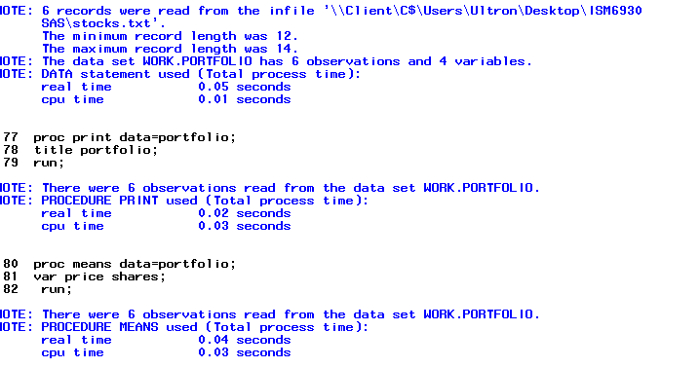

**OUTPUT**

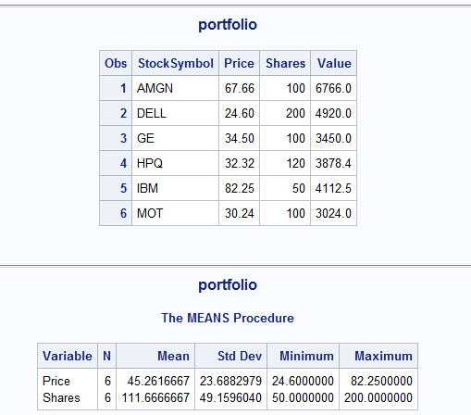

1. Given the program here, add the necessary statements to compute four new variables:
   1. Weight in kilograms (1 kg=2.2 pounds). Name this variable WtKg.
   2. Height in centimeters (1 inch = 2.54 cm). Name this variable HtCm.
   3. Average blood pressure (call it AveBP) equal to the diastolic blood pressure plus one-third the difference of the systolic blood pressure minus the diastolic blood pressure.
   4. A variable (call it HtPolynomial) equal to 2 times the height squared plus 1.5 times the height cubed.

Here is the program for you to modify:

data prob2;

input ID $

Height /*in inches*/

Weight /*in pounds*/

SBP /*systolic BP*/

DBP /*diastolic BP*/

< place your statements here >

datalines;

001 68 150 110 70

002 73 240 150 90

003 62 101 120 80

;

title “Listing of PROB2”;

proc print data=prob2;

run;

**CODE**

**data** prob2;

input ID $

Height /*in inches*/

Weight /*in pounds*/

SBP /*systolic BP*/

DBP /*diastolic BP*/;

WtKg = Weight * **2.2**;

HtCm = Height * **2.54**;

AveBP = DBP + (SBP - DBP) / **3**;

HtPolynomial = **2** * Height ** **2** + **1.5** * Height ** **3**;

datalines;

001 68 150 110 70

002 73 240 150 90

003 62 101 120 80

;

**run**;

title “Listing of PROB2”;

**proc** **print** data=prob2;

**run**;

**LOG**

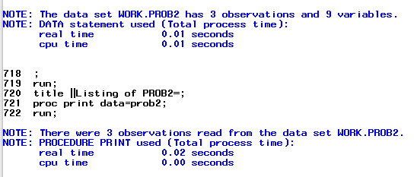

**OUTPUT**

